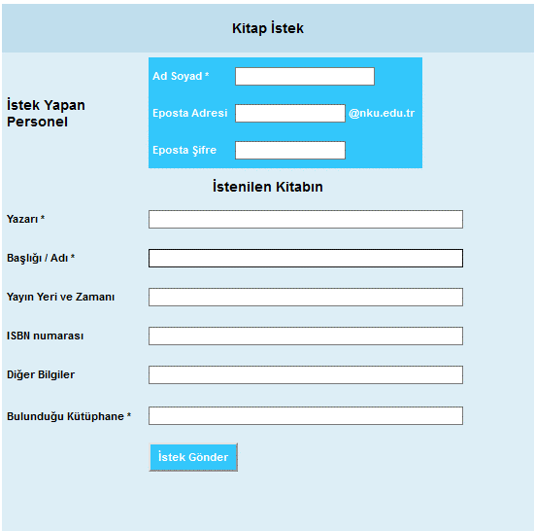
ONLINE FORM

ERİŞİM LİNKİ
http://kutuphane.nku.edu.tr/BelgeSa%C4%9Flama/0/s/6255/6513

